Communities
Sustainability Report 2026 – Chapter 5 (draft by Tom Berger)
Noah Fischer · 24 September 2026
Renewable energy is built in somebody's landscape. We want every community near our assets to see a real benefit.

Community funds
Fund | 2026 YTD | Projects
Kestrel Ridge Community Benefit Fund | GBP 252,000 | 14
Harrow Bay Coastal Fund (new) | GBP 125,000 | 9

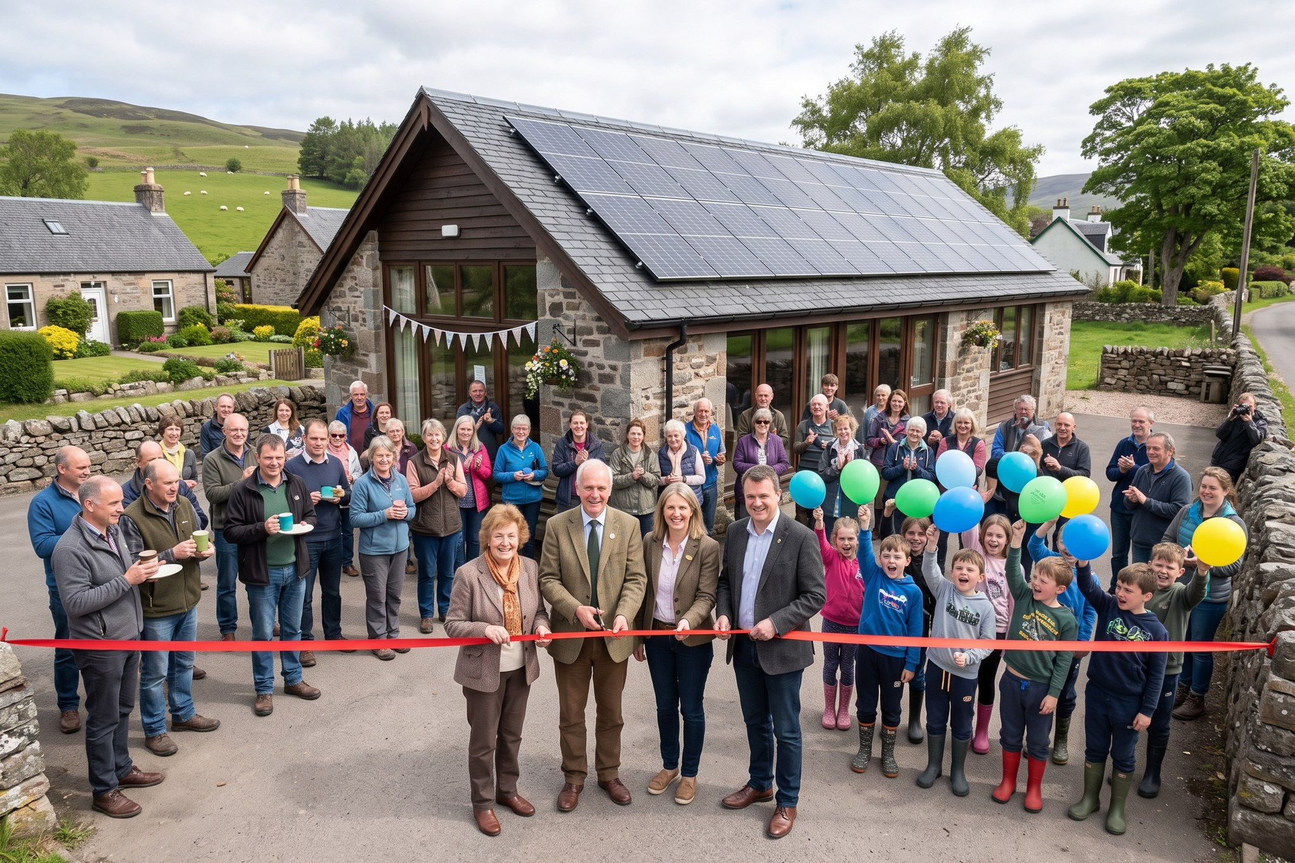
Opening of a community hall solar roof funded by the Kestrel Ridge fund.

Listening at Millbrook
We held public consultations on 11 March, 20 May and 16 September 2026. Residents raised glare for nearby homes, construction traffic on Mill Lane, skylark nesting habitat and the view from the public footpath. In response we moved panels 60 m back from Mill Lane cottages, proposed a construction route avoiding the village centre and added 24 skylark plots.

Grievances
We received 23 complaints in 2026 YTD (2025: 17), mainly about construction traffic at Eastholm; 21 are closed.

